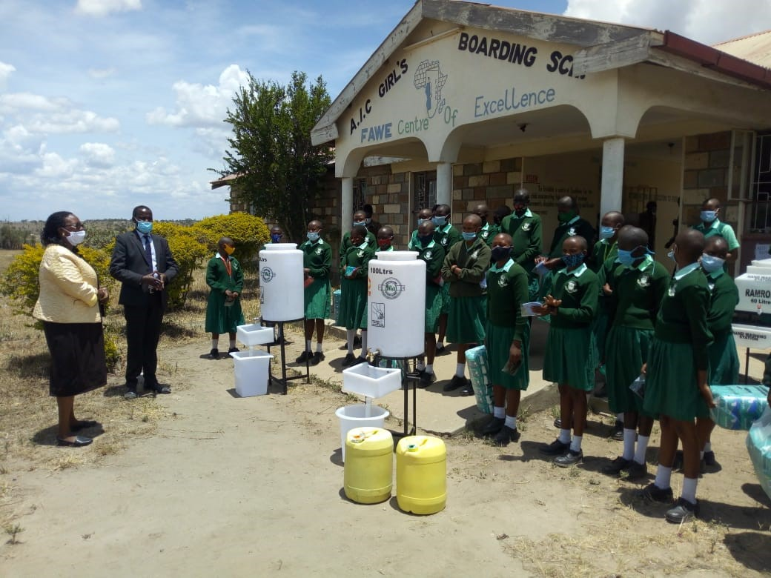
Delivery of supplies that supports prevention of COVID 19 to AIC Girls Primary School in Kajiado County, Kenya. December 2020/CARE Kenya.

COVID-19 CRISIS

Background
CARE Kenya Staff disinfecting latrine in Hagadera -Dadaab Refugee Camp, Kenya, December 2020/CARE Kenya.
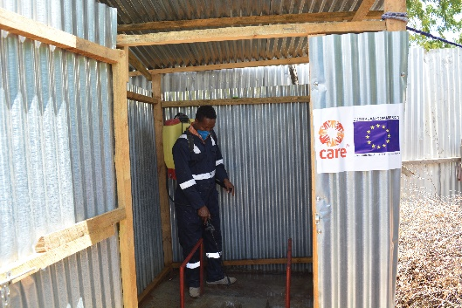
CARE is quickly mounting a global response to the COVID-19 pandemic – which threatens to overwhelm healthcare resources, particularly in countries with weak public health infrastructures. We are building on our experience responding to outbreaks of infectious disease in vulnerable communities – taking particular note that emergencies, including health crises, tend to disproportionately affect women and girls.

CARE benefits from strong relationships with national and local authorities in the 100 countries where we work, longstanding community links, and decades of experience in health interventions. Our response to the Ebola virus epidemic, among others, serves as a model for how CARE supports community preparedness and prevention during serious public health emergencies.

Partnerships for Prevention
Globally, CARE is coordinating our COVID-19 response with WHO, the U.S. Centers for Disease Control and Prevention (CDC), and other leading public health and humanitarian actors, as well as national governments, county governments and local community leaders. CARE’s response to infectious disease, such as the West African Ebola outbreak in 2014-15, has centered on bolstering community mobilization activities to raise public awareness and promote safe health and hygiene behaviors. In our Ebola response, we were able to engage effectively, thanks to our existing community ties in countries heavily affected by the outbreak. Our response to COVID-19 will similarly build on close cooperation with community members and local government structures.

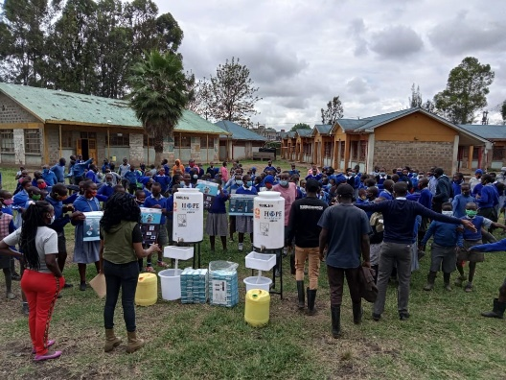
COVID-19 and CARE Kenya’s Response
Delivery of supplies that supports prevention of COVID 19 to AIC Girls Primary School in Kajiado County, Kenya. December 2020/CARE Kenya.

CARE places a special focus on women and girls, who often face specific challenges during emergencies. Based on CARE’s experience, we can anticipate disproportionate economic and social effects on women and girls. We are preparing accordingly to support women in dealing with the fallout of a devastating pandemic and its primary consequences.

As at November 30, the Kenya Government has confirmed 83,618 positive cases, 1469 deaths and 55,344 recovered which now raises the level of efforts in place to contain the spread. With the fast increase of the COVID 19 positive cases in Kenya, the government has continued to institute stringent surveillance and prevention measures.

CARE International founded in 1945 is a leading humanitarian and development organization fighting global poverty. CARE places special focus on working alongside women and girls because, equipped with the proper resources, they have the power to lift whole families and entire communities out of poverty. CARE commenced its humanitarian programme in Kenya in 1968. Since then CARE has built both development and humanitarian programs including refugee operations, emergency response, Water, Sanitation and Hygiene (WASH), livelihoods, food security, climate change adaption, sexual reproductive and maternal health, women and girls economic empowerment, and youth employability. CARE plans to integrate and implement the following strategic interventions in the various thematic areas to address the COVID-19 Pandemic:

CARE Kenya’s COVID-19 response strategy rests on several key pillars. Examples include:

- Community engagement: Building on our existing programming, CARE will provide guidance to the communities and partners we work with on risks, prevention, signs and symptoms. Women and girls remain central to this effort, as they frequently play the primary role in household hygiene.

- Hygiene promotion: CARE will draw on our extensive experience in promoting hand washing – a simple and hugely effective measure everyone can take to reduce the risk of COVID-19. Our water, sanitation and hygiene teams – along with other CARE program teams – will introduce or scale up hand washing activities, such as the provision of soap and handwashing stations, conducting hand washing demonstrations, and tackling barriers to good hand hygiene.

- Water supply: We are exploring opportunities to scale up safe water supplies to facilitate good personal and household hygiene.

- Food and nutrition support: CARE will support provision on nutritional guides to communities most at risk of starvation and together with partners explore opportunities for food emergency relief especially focused to lactating mothers, infants, people with special needs and the elderly. Based on the CARE’s response to pandemic outbreaks, restrictions imposed in quarantine often result to increased starvation and lack of access to basic food.

- Gender and protection: Recognizing the disproportionate impact of public health crises on women and girls, CARE is working to strengthen the policies and practices we implement in all of our emergency response work. This includes our focus on protection for vulnerable populations, including women and girls, given the elevated risk of sexual and gender-based violence during emergencies. Increasing their (HER) voice and agency as they respond and recover from the emergency.

- Sexual and reproductive health and rights (SRHR): CARE is prioritizing the continuation of ongoing SRHR programming, as healthcare systems – particularly in lower-resource countries – are diverting resources to the COVID-19 response. Based on CARE’s experience responding to the Ebola outbreak in West Africa, school closures and decreased access to SRHR services are likely to result in increased rates of unplanned pregnancy.

- Psychosocial support: The emotional toll of a global health crisis cannot be underestimated – with effects on both healthcare workers and people who are being treated for COVID-19. CARE will work to bolster the availability of resources, such as psychological first aid, mental health support and other related counseling support services for vulnerable populations.

CARE Kenya’s Ongoing Response:
Below are a few early examples of how CARE Kenya is ramping up support for COVID-19 preparedness and prevention:

In Dadaab Refugee Camp, the first case was reported on 18th May 2020, to date there are total of 239 (176 male& 63Females) confirmed cases of Covid-19 infection (95 refugees and 144 aid workers). Total of Covid-19 related deaths are 7, total recoveries are 146. CARE Kenya in collaboration with UNHCR and Red Cross tested staff who are due and would be travelling for leave in month of November 2020.

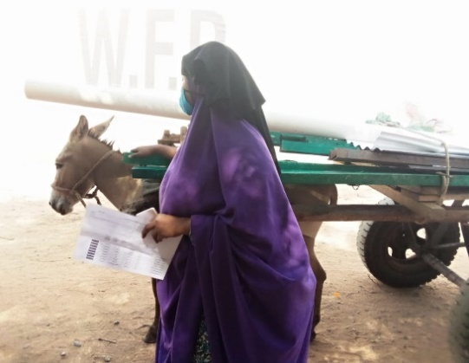
CARE has made sure water supply to the refugees in the three camps is very smooth with no major interruptions. Scheduled and routine servicing and maintenance is carried out by the plant maintenance unit (PMU) team all the water pumping equipment at all the 22 boreholes across the 3 camps. CARE is also repairing the water infrastructure in all the schools.

Latrine construction materials distribution in Hagadera-Dadaab camp November 2020/CARE KENYA.

A total of 2672 Household visits with a population of 14,007 persons across the camps were conducted by hygiene promoters sensitizing the community on the importance of proper and frequent hand washing, social distancing, use of nose masks and other measure as directed by the ministry of health in controlling the Covid-19 pandemic.

CARE Kenya with support of UNHCR, through its Water, Sanitation and Hygiene (WASH) department continue to supply clean and safe water throughout the day to enable people observe hygiene measures. CARE Kenya in collaboration with Film Aid and MSF continue to carry out mass sensitization using public address on control and prevention of Covid-19 in the camps.

In Marsabit County, CARE Kenya through the FSD project has been guiding Community Based Facilitators to advance discussions on Gender Based Violence during VSLA meetings. Most Gender Based Violence in the context of COVID – 19 emerges from the fact that women are enclosed in their households more so in the reduced mobility, which aggravates men position as sole providers for the household budgets. A cash transfer to the women would thus reduce aggressions towards them since they will be contributing to household budgets leading to the male counter parts appreciating their contribution. The project teamed with Equity Bank for loans to project beneficiaries to finance their businesses. Most Income Generating Activities (IGAs) are doing well hence providing women with income which they are using to supplement household budgets. Banning of social gatherings has affected Village Savings Loaning Associations (VSLAs) group meetings and effective service delivery.

The County Government has notified development partners on gaps related to strengthening the health facilities in provision of equipment like Personal Protective Equipment’s (PPEs) for health care workers, Protective Infra-Red thermo-scanners and facilitation of County Government to train health care workers. The other prominent gap would be the public sensitization through talk shows in Local FM radio stations and dissemination of Information education materials.
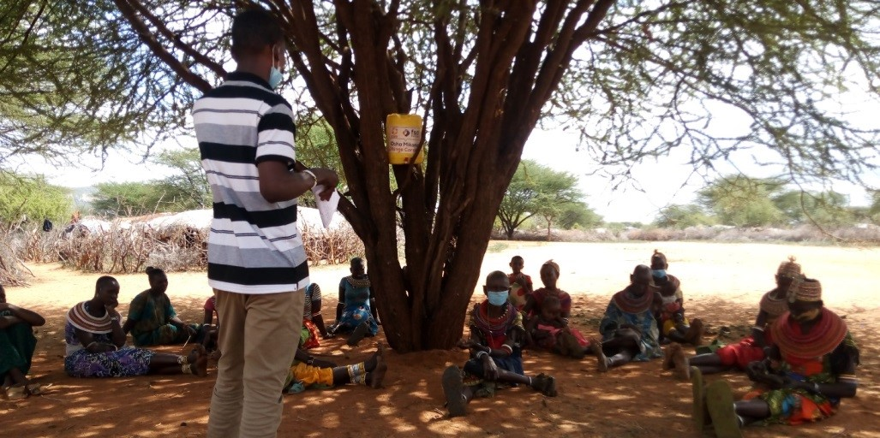
Lpusi group in Lontolio being trained on Business ideas and advantages of being in a group. December 2020. /CARE Kenya.

Over the last 8 months, the FSD Project made efficient and effective adjustments that improved quality and reach include: Integrating peer learning with COVID 19 and its preventive measures (topics) during group meetings since it reduced the chances of contracting the virus; Monthly group meetings were reduced to sub groups- meetings conducted in sub groups of 4-5 people - activity based monitoring frequently was also done on weekly basis with project partners and improved visual integrated monitoring approaches.

In the informal settlements of Nairobi, through the Adolescent Empowerment Project (AEP) implemented in Mukuru and Kajiado Central sub-County, CARE Kenya is now working with Mteja Technologies, a mass messaging service providers, to send messages to adolescents through their parents and guardians to assess how they are coping during this period; Adolescents Sexual Reproductive Health (ASRH) and Financial literacy messages that are being sent to the adolescents through the mass messaging Mteja platform has improved quality and reach in the programming. Approximately 70 individuals have received direct messages, and 88 individuals received indirect message in the reporting periods. With only a few classes (classes 4& 8, & form 4) having reopened school, AEP sessions are not being conducted. The AEP project completed delivery of hand washing facilities, sanitizers, and sanitary towels in Mukuru and Kajiado to AEP beneficiaries and community members. There are existing gaps within the AEP Covid-19 response that require more support and these include: access of phones and network by some AEP adolescents and parents/ guardian when COVID 19 prevention messages are sent. AEP is supporting adolescents by creating an enabling environment for those doing COVID-19 related income generating activities (IGAs) such as making face masks and liquid soap. AEP links the adolescents to ready market for their products mainly in schools. Communication with teachers and facilitators through WhatsApp platform has enabled the AEP team, partners, teachers and facilitators stay in touch and get to know what is happening on the ground as they follow up with the adolescents in the communities.

In Garissa County, CARE Kenya through the Kenya Rapid Program has been implementing a UNICEF Floods Emergency Project from 10th August to 9th November, 2020 with activities contributing to the indicators here on COVID-19 response. However, the proposal did not apply CARE’s gender marker. Its activities though are adapted to meet the distinct needs of women, men, boys and girls identified. The monitoring tools were designed to collect gender disaggregated data. Hence the project was gender sensitive. A total of 6,437 households have been reached directly through this project. The main needs of the response team include Personal Protective Equipment supply replenishment, resilient water supply and storage structures and trainings of home based care givers on case management. Over the last 8 months, K-RAPID Program developed COVID-19 Standard Operating Procedures to enable the team to resume work during COVID-19 pandemic in June 2020. The SOPs were in line with Ministry of Health guidelines and covered COVID-19 prevention measures for CARE Garissa office, vehicle, distributions, community trainings, PPE use and action for staff who feel ill. The CARE Garissa team finalized the CI ERF COVID-19 response and is now is closure stages of Kenya Resilient Arid Lands Partnership for Integrated Development under the SDC cost extension running to 28th Feb, 2021.

In Mandera County, CARE through the BORESHA project that targets all genders in the cross border of Ethiopia-Kenya-Somalia has applied Gender Based Violence (GBV) in the development of the proposal for DFID on COVID-19 response. The proposed activities include developing and incorporating messaging to safely raise awareness on the available GBV services including the hotline & service providers, referral procedures and recommendation ; mapping out available GBV and protection services and existing referral mechanisms, update regularly (monthly), and disseminate. Government directives on social distancing, staying at home have had significant negative impact on the implementation of the BORESHA project. Due to strategic donor interests in the ongoing interventions calls by the county government to have the project resources redirected to address COVID-19 have been futile. So far, over 2098 households have been beneficiaries of the BORESHA project COVID-19 response. The County Government has notified development partners on gaps related to strengthening the health facilities in the provision of equipment like Personal Protective Equipment’s (PPEs) for health care workers, Protective, Infra-Red Thermo-scanners and facilitation of County Government to train health care workers. Over the last 8 months, BORESHA Horn of Africa Project made efficient and effective adjustments that improved quality and reach.

In Western Kenya (Siaya, Kakamega, Bungoma, Counties) the Global Handwashing Day was commemorated in the 3 counties of Migori,Kisumu and Siaya where handwashing with soap was highlighted as an effective prevention measure to COVID-19.In light of the public health directives issued by the national government on social distancing to curb COVID-19 pandemic the Village, Savings and Loans Associations (VSLA) project team holds weekly virtual meetings with the community-based trainers to exchange feedbacks from the VSLA groups on the existing contingency measures adopted to safeguard their transactions. In the past 4 Weeks, the Children Safe Drinking Water (CSDW) project has reached over 231 households with messaging on COVID 19 and WASH behaviours through the Social Analysis and Action. The most beneficial adjustment that was adapted was the use of digital channels to reach the project beneficiaries with trainings and technical support by SBOSH-GIZ project and Community Score Card Facilitators and SAA facilitators for CSDW Project that included interactive sms chatbot for financial literacy targeting dairy cooperative members and use of zoom and whatsapp platforms for calls whenever necessary. A stronger focus on behavior change that is clear and the target audience defined would go along if our response was to be redesigned from the beginning.

Across the entire country, CARE Kenya’s Women Voice and leadership (WVL) Project is providing Rapid Response Funding in partnership with Urgent Action Fund Africa (UAF Africa). These rapid response grants are able to timely and nimbly address the gendered impacts of COVID 19 for women and girls including the most marginalized populations including gender non-conforming groups. The WVL Kenya partnership has applied gender marker in the COVID 19 response to design and review its interventions to fully align to the gendered impacts of COVID 19 as per the recommendations from the Gender Assessments done. The COVID 19 Gender Assessment Report was launched and released with clear policy and recovery recommendations for consideration. Find Link below to access the report; https://data.unwomen.org/publications/covid-19-gender-assessment-kenya.
Government directives concerning the extended Night curfew from 10pm to 4am by 60 days from 4th November 2020 has affected the ability of Women Rights Organizations (WRO’s) to respond to certain emergencies like to SGBV cases especially the ones happening within the curfew hours therefore increasing the vulnerability and exposure of most survivors/ victims to SGBV. This has also come with insecurities and night robberies during the curfew hours. The reopening of schools on 4th of January 2021 has also given an opportunity for girls and boys to continue learning and has enabled the teachers to get back to employment and earning a source of income.

